ASSIGNMENT – 3

NAME:M.SWATHI

REG.NO:192111059

SUBJECT:OBJECT ORIENTED PROGRAMMING WITH C++

SUBCODE:DSA0163

SINGLE INHERITANCE:

#include <iostream>

using namespace std;

class Person {

int id;

char name[100];

public:

void set()

{

cout << "Enter the Id:";

cin >> id;

cout << "Enter the Name:";

cin >> name;

}

void display()

{

cout << endl <<"Id: "<< id << "\nName: " << name <<endl;

}

};

class Student : private Person {

char course[50];

int fee;

public:

void set1()

{

set();

cout << "Enter the Course Name:";

cin >> course;

cout << "Enter the Course Fee:";

cin >> fee;

}

void display1()

{

display();

cout <<"Course: "<< course << "\nFee: " << fee << endl;

}

};

int main()

{

Student s;

s.set1();

s.display1();

Person p;

p.set();

p.display();

return 0;

}

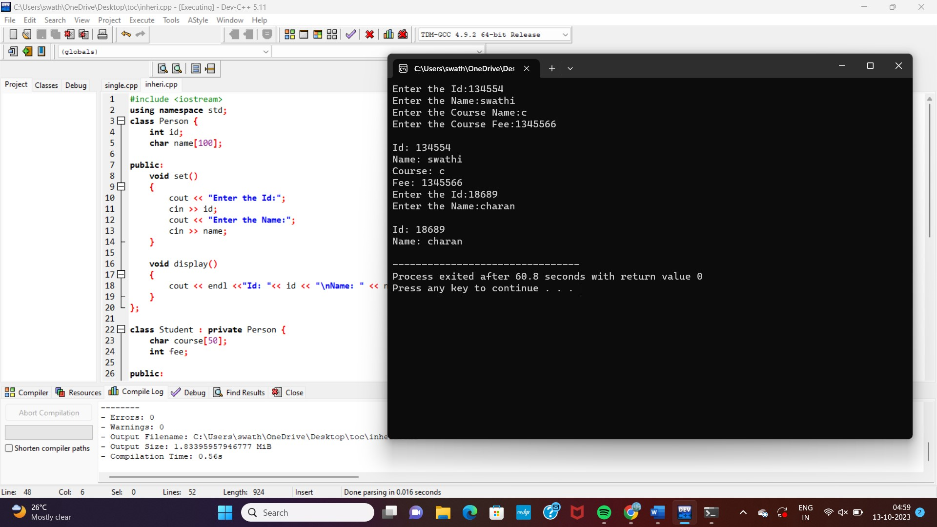

MULTILEVEL INHERITANCE:

#include <iostream>

using namespace std;

class A

{

protected:

int a;

public:

void get_a(int n)

{

a = n;

}

};

class B

{

protected:

int b;

public:

void get_b(int n)

{

b = n;

}

};

class C : public A,public B

{

public:

void display()

{

std::cout << "The value of a is : " <<a<< std::endl;

std::cout << "The value of b is : " <<b<< std::endl;

cout<<"Addition of a and b is : "<<a+b;

}

};

int main()

{

C c;

c.get_a(10);

c.get_b(20);

c.display();

return 0;

}

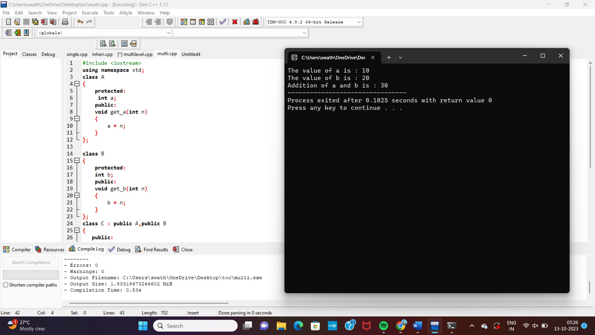

HEIRACHIAL INHERITANCE:

#include <iostream>

using namespace std;

class Shape

{

public:

int a;

int b;

void get_data(int n,int m)

{

a= n;

b = m;

}

};

class Rectangle : public Shape

{

public:

int rect_area()

{

int result = a*b;

return result;

}

};

class Triangle : public Shape

{

public:

int triangle_area()

{

float result = 0.5*a*b;

return result;

}

};

int main()

{

Rectangle r;

Triangle t;

int length,breadth,base,height;

std::cout << "Enter the length and breadth of a rectangle: " << std::endl;

cin>>length>>breadth;

r.get_data(length,breadth);

int m = r.rect_area();

std::cout << "Area of the rectangle is : " <<m<< std::endl;

std::cout << "Enter the base and height of the triangle: " << std::endl;

cin>>base>>height;

t.get_data(base,height);

float n = t.triangle_area();

std::cout <<"Area of the triangle is : " << n<<std::endl;

return 0;

}

